© Doily Dobermans 2011

BISS GCH Cambria’s
Nemiroff CGC
“BRIX”
vWD Clear, Thyroid Normal,
OFA Hips, Elbows Good
Black, Type #3 (Black & Reds Only)
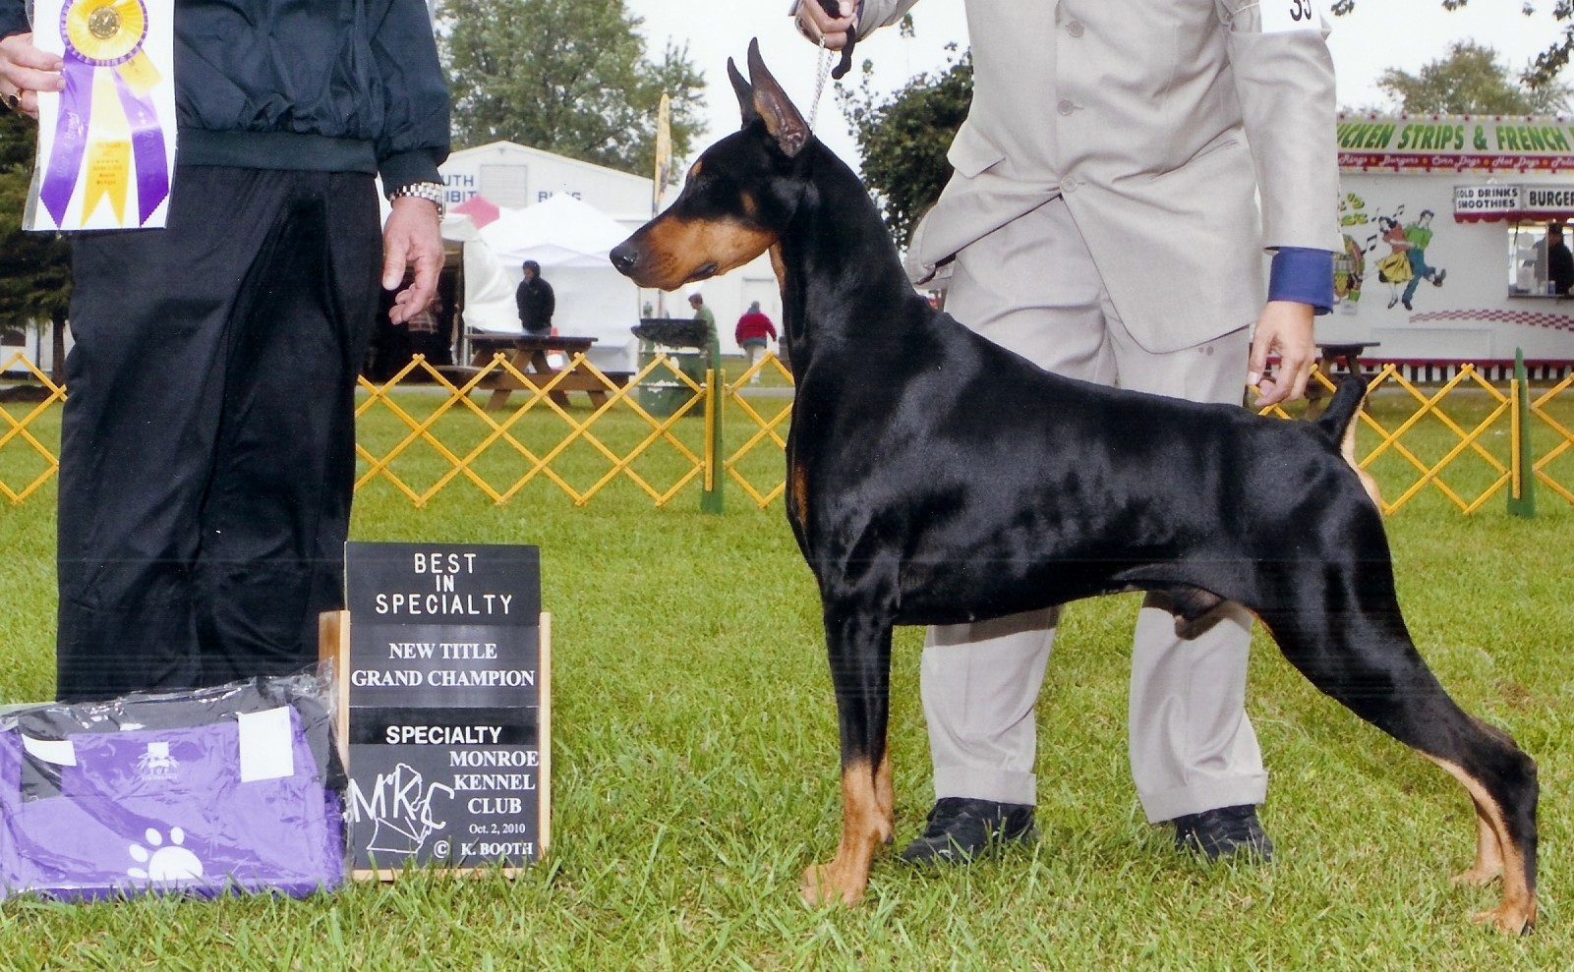
Arg. /China CH Baden
Baden Voodoo
Multi BISS-Group & BOB Winner. DCA Top 20 Contender 2004
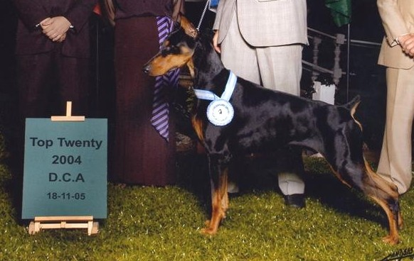

Am/Arg/Brz/Urg CH
A’Monde’s Tidal Wave
Catriel WAC
Thyroid Normal, OFA
Hips Elbows Good
Am/Int/Mex CH Arg/Brz GRCH Nello’s Lex Luthor WAC, vWD Carrier, Thyroid Normal, OFA Good

CH Carolon’s Show N Tell
WAC, Thyroid Normal, OFA Good

Arg. CH Baden Baden
Moira

Am/Int/Mex CH Arg/Brz GRCH Nello’s Lex Luthor WAC

BRIX-HALO PUPPIES

Baden Baden Caira
Best Brood Bitch, DCA 2000

Rebayla’s Vodkatini Amazona, vWD Clear,
OFA Hips Good
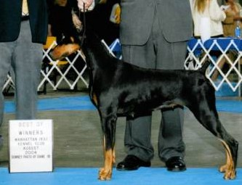
CH Cambria’s Irish Rebellion WAC
vWD Clear, OFA Excellent

CH Cambria’s Cavalleria LC-11

CH Orion’s Raspberry Beret

CH McKella’s Yellowbrick Road, vWD Carrier
Thyroid Normal
OFA Good
CH Merkur’s Hit the Road
CanMultiBISAmMulti Group Winner

CH Athena’s Spitfire
OFA Good

U-CH Lyndobe’s Halo N’ Horns
“Halo”
vWD Carrier, Thyroid Normal
Black, Type #3 (Black & Reds Only)
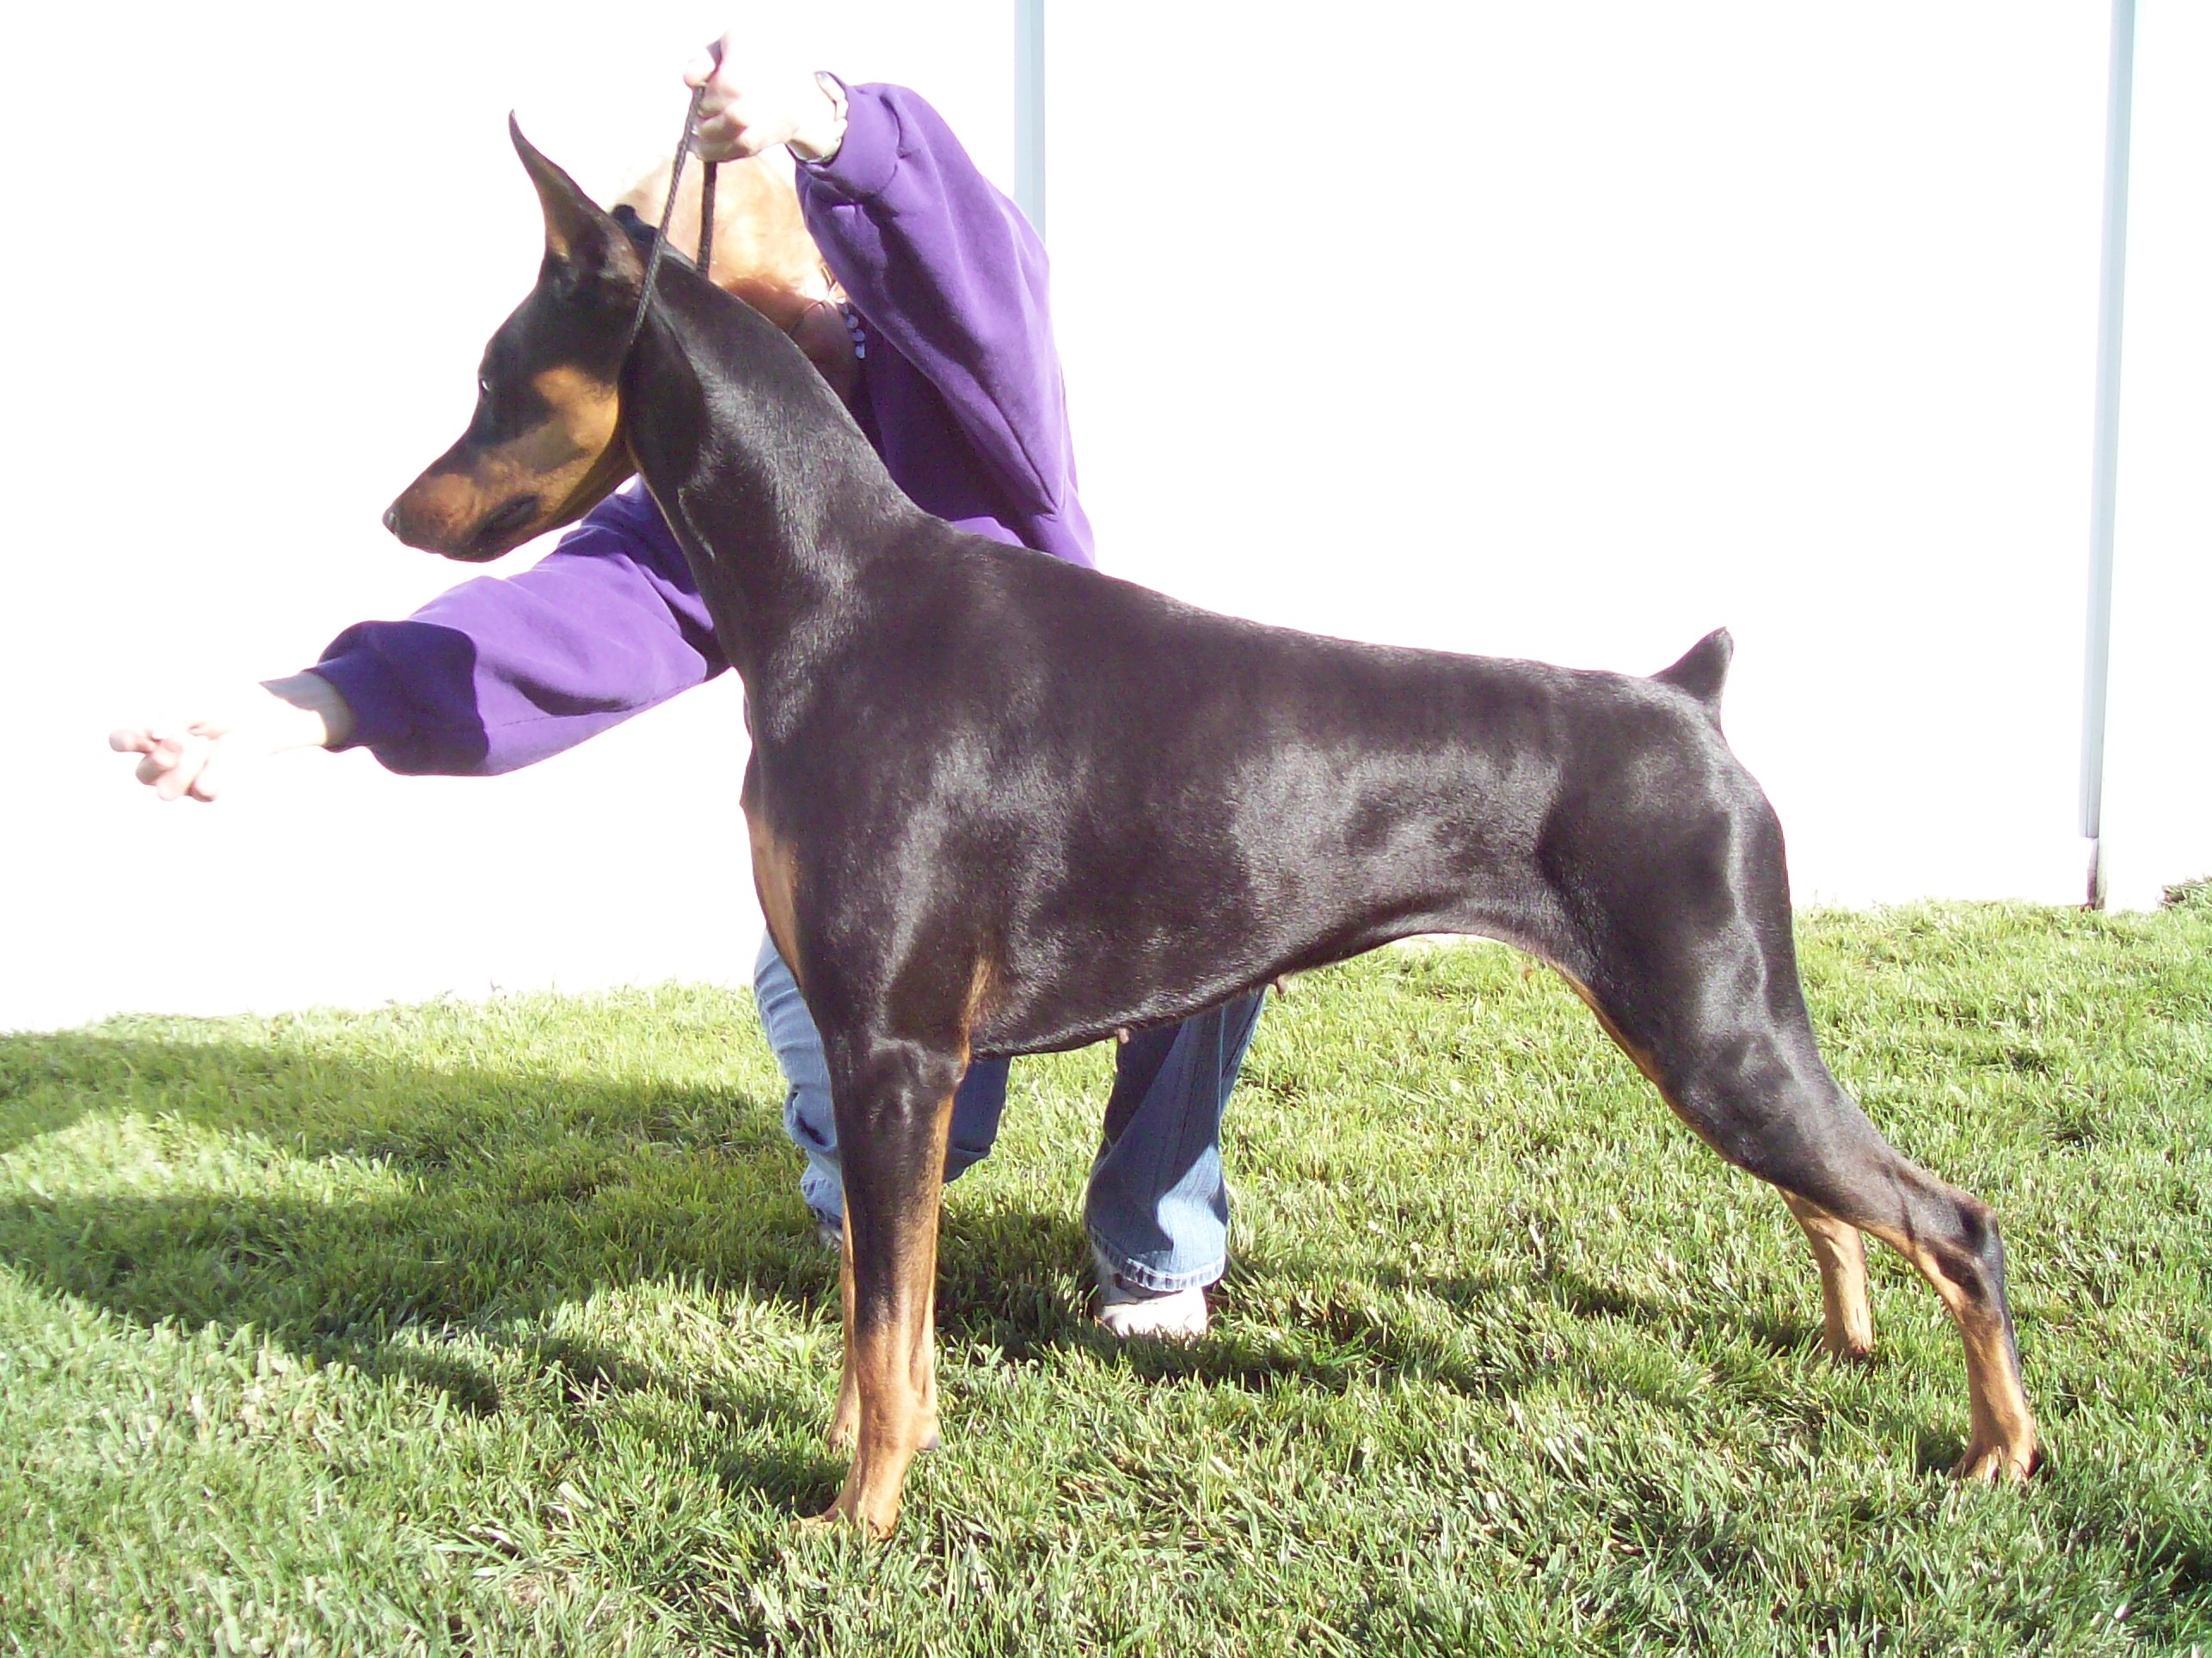
Am/Int/Nat./UKC
CH Briarwood Breakout
vWD Clear, Thyroid Normal, OFA Fair
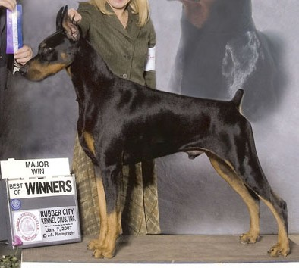
CH Eldorado’s Cast A Spell
vWD Carrier, OFA Good
Thyroid Normal

CH Briarwood Storms’ A Brewin’
LC-12, vWD Clear, OFA Good

CH Eldorado’s Cateras Kahlua
OFA Good

Briarwood Strom Enya
OFA Good

CH Briarwood After Shock
vWD Carrier, OFA Excellent
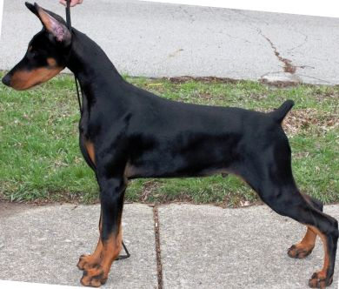

Briarwood Incantare
Blue Female

U-CH Lyndobe’s Tell It All Tally, CGC CD, WAC
vWD Carrier, Thyroid Normal, OFA Good
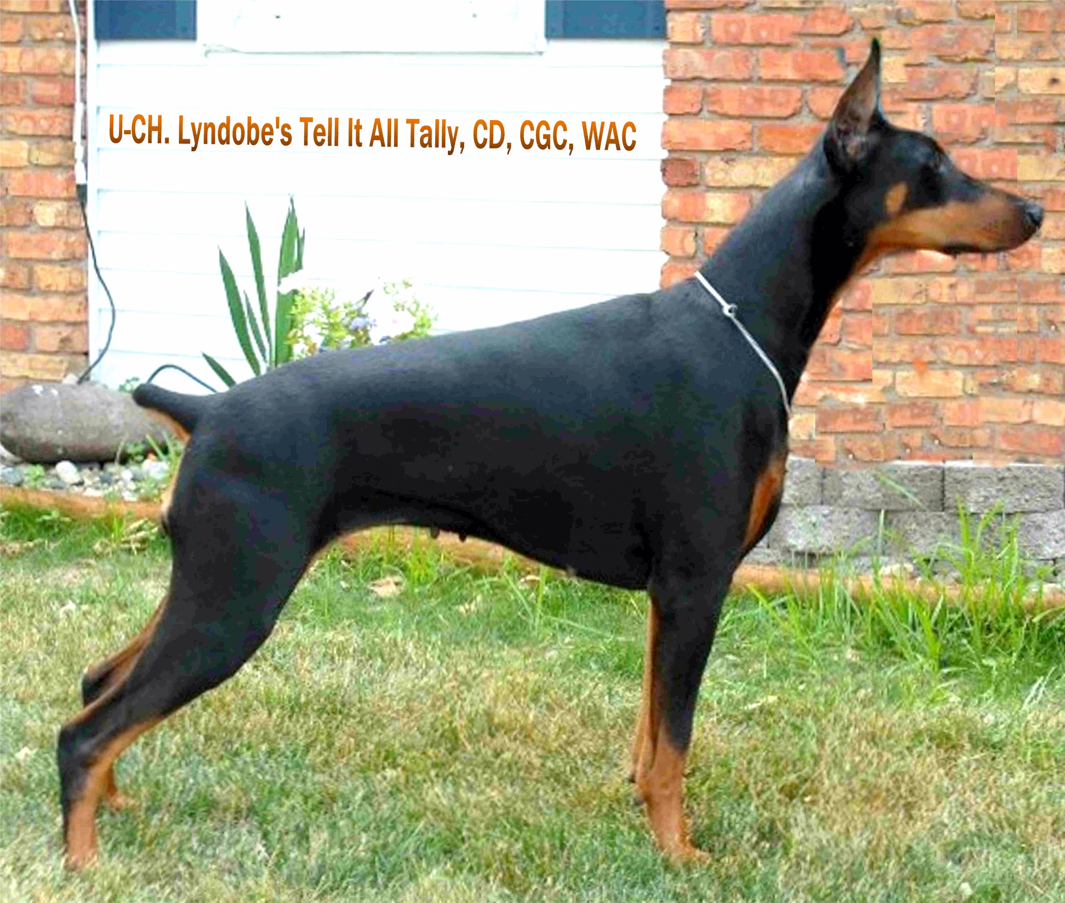
CH Nova’s Zodiac V Kelview
vWD Clear
Best Futurity Junior at 2004 Nationals

CH Cambria’s Irish Rebellion
CH @ 7 mos. , vWD Clear, OFA Exc.

CH Nova’s Zolara V Kel-View
BOB at 2001 Nationals, OFA Good

Am/Can/U-GRCH Lyndobe’s Do It All Dixie
Multi ROM Producer
CH Gunzhof’s Texas Treasure LC-12

Can/U-GRCH Lyndobe’s All That Glitter’s, Multi ROM Producer

